|  |  |  |  |  |  |
| --- | --- | --- | --- | --- | --- |
| X | 1 | 5 | 7 | 9 | 12 |
| F(x) | 10 | 15 | 12 | 15 | 21 |

**Input:**

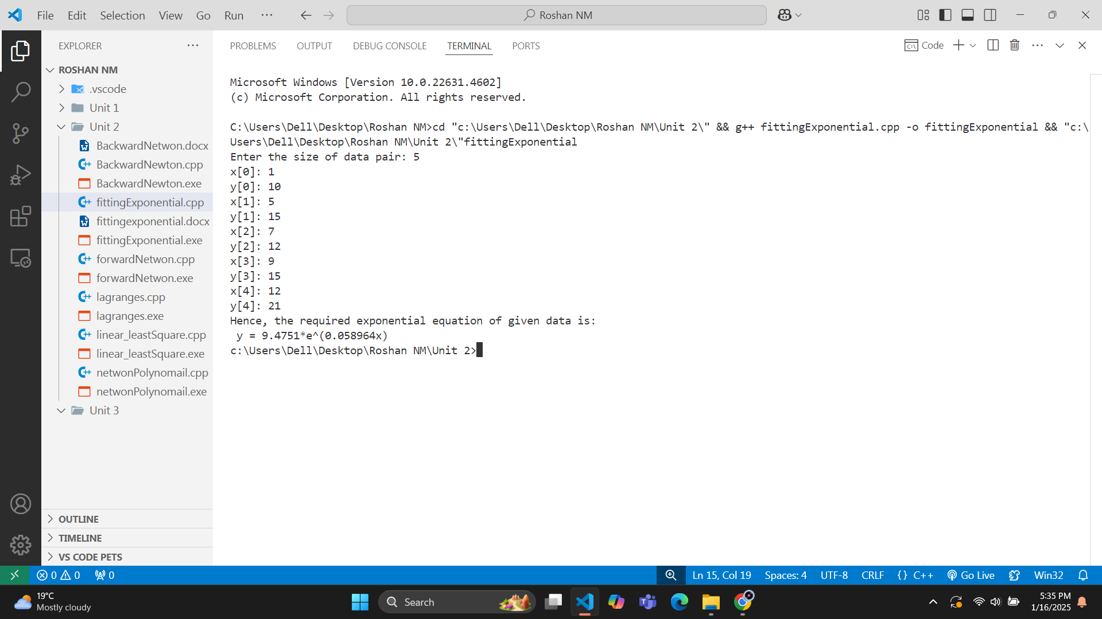**Output:**

|  |  |  |  |  |  |
| --- | --- | --- | --- | --- | --- |
| X | 2 | 4 | 6 | 8 | 10 |
| F(x) | 4.077 | 11.084 | 30.128 | 81.897 | 222.62 |

**Input:**

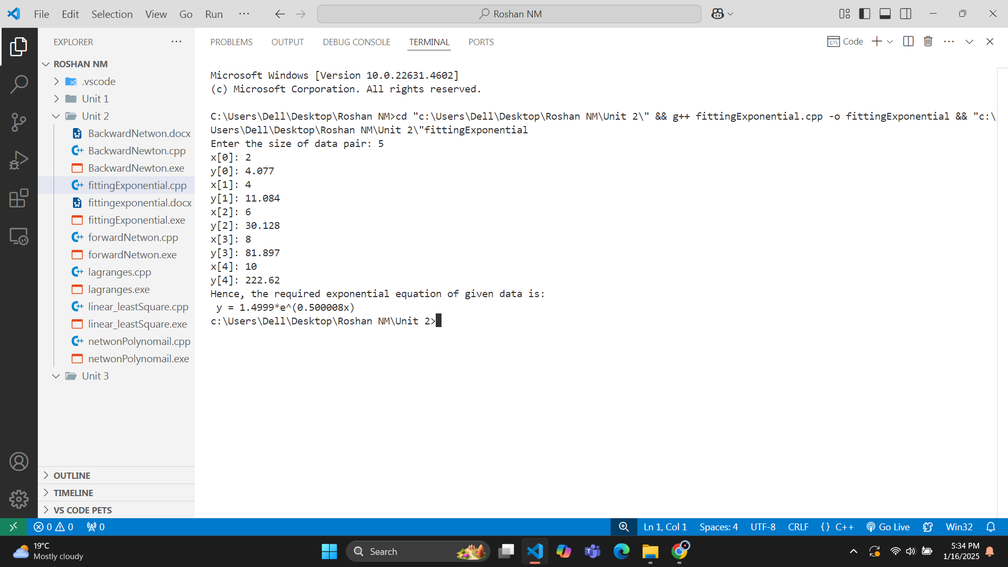**Output:**